Nord Lock Washers
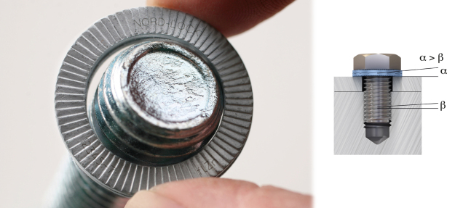 | The Nord-Lock original washers  Nord-Lock washers secure bolted joints with tension instead of friction. It is a high quality product with documented success in many industries worldwide.
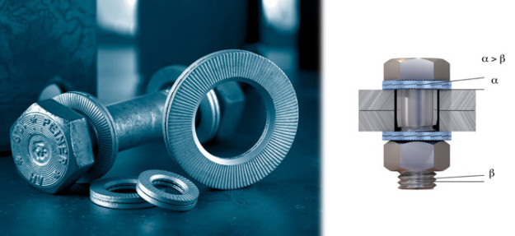 | Steel construction washers  Based on the leading Nord-Lock wedge-locking technology, the Nord-Lock steel construction washers (SC) are specially designed for steel construction applications and to fit HV sets and HR sets (bolts and nuts in accordance to the European standard EN 14399-4 and EN 14399-3).
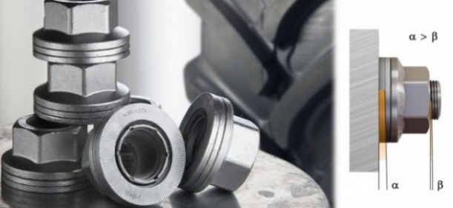 | The Nord-Lock wheel nut  The Nord-Lock wheel nut safely secures wheels on on-road and off-road heavy vehicles by maintaining high clamping force even under extreme operating conditions.
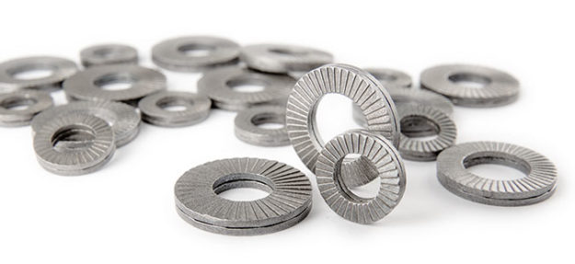 | Combi bolt washers  Nord-Lock Combi bolt washers are specifically designed to be captivated on a bolt, so called SEMS. The washers are based on our proven wedge-locking technology but have reduced inner diameter to not fall off the bolts after the thread is added.
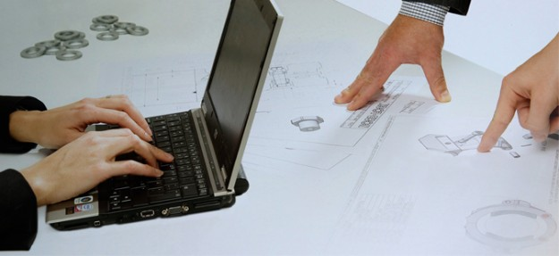 | Customer specials  Over the years, the Nord-Lock Group has entered several partnerships to develop unique solutions for the most creative designs. Should the product to suit your needs not be available on the market, we are able to help you find the optimum solution.

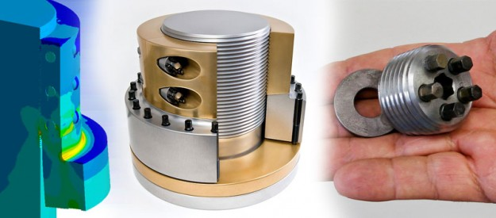 | Special designs  Our engineers can design optimum bolting solutions for your unique applications requirements.

